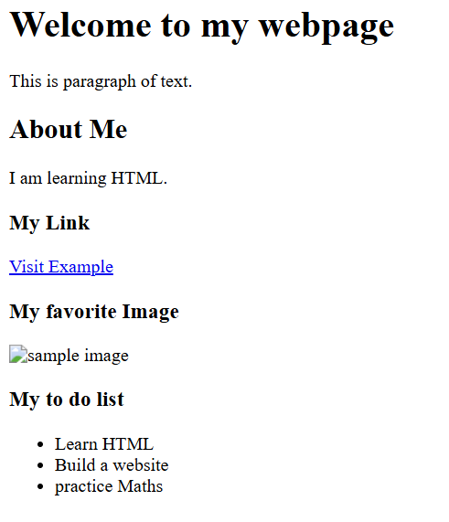
Practical 1 HTML
<!DOCTYPE html>
<html>
<head>
<meta charset="UTF-8">
<title>My first Webpage</title>
</head>
<body>
<h1>Welcome to my webpage</h1>
<p>This is paragraph of text.</p>
<h2>About Me</h2>
<p>I am learning HTML.</p>
<h3>My Link</h3>
<a href="https://example.com" target="_blank">Visit Example</a>
<h3>My favorite Image</h3>
<img src="file:///D/images/image.jpg" alt="sample image">
<h3>My to do list</h3>
<ul>
<li>Learn HTML</li>
<li>Build a website</li>
<li>practice Maths</li>
</ul>
</body>
</html>

